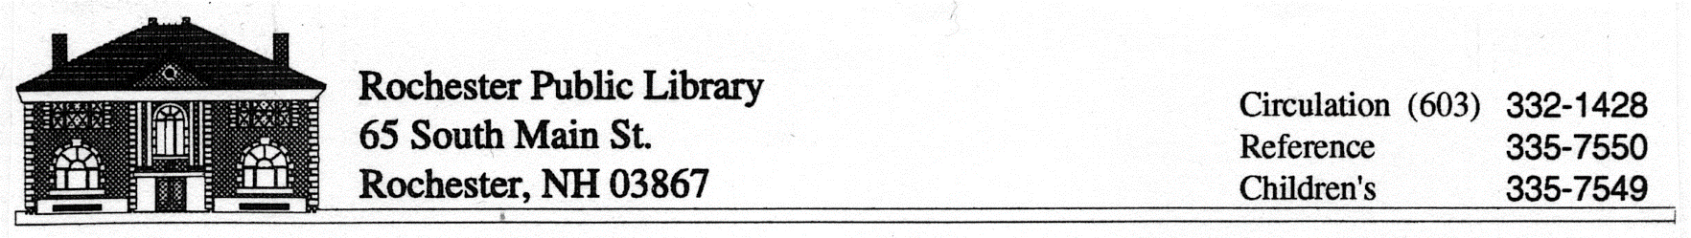
REQUEST FOR RECONSIDERATION OF LIBRARY MATERIALS

Title __________________________________________________________________

Author ________________________________________________________________

Publisher _______________________________________________________________

Your Name ______________________________________________________________

Address ______________________________ Telephone _________________________

City ____________________________State ___________Zip Code ________________

You represent:
_____ self
_____ organization (Please identify _______________________________)

Please use additional pages if more room is needed.

- What brought this item to your attention?

- Did you read the entire book? Watch the entire movie? If not, which parts did you read/watch?

- What do you object to in the book/item? (Please be specific, cite pages)

- Do you think the item has merit?

- Have you read reviews of this item? (If yes, please specify)

- To whom would you recommend this item?

- What action would you like the library to take regarding this item?

Signature: __________________________________________________Date:________________

For Internal Use Only:

Reviewed By:___________________________________ Date:_______________

Committee Review:_______________________________________

Action Taken:__________________________________________________________
This form will be kept on file for 1 calendar year.

